Analysis of Foreign Direct Investment in Latin America and the Caribbean
Stephany Silene Infanzón Vargas
Master student of economics
Financial University under the Government of Russian Federation
International Financial Faculty, Moscow, Russian Federation
e-mail: estefaniinfanzon@hotmail.com

- General outlook of Latin America and the Caribbean:
Latin America and the Caribbean continue to face challenging economic conditions, amid domestic weaknesses and a less supportive external context, particularly lower commodity prices. After economic growth of 1.3 % in 2014, the region improves moderately to an average growth of 2.4 % in 2015, although with considerable cross-country differences and significant downside risks. Among the subregions, the economies of Mexico and Central America were forecast to expand by 3.5 % in 2015, up from 2.6 % in 2014. By contrast, South America was expected to grow by only 1.9 %, compared to 0.7 % in 2014. The Caribbean economies were expected to expand by 3.8 %, similar to 2014. Now we know that the scenery is different because the growth in Latin America and Caribbean dropped below 1 percent in 2015 and is expected a modest recovery in 2016.South America’s growth weighed down by lower commodity prices and the situation of Mexico, Central America, and Caribbean is better. The region needs to tackle long-standing structural problems to raise investment, productivity
Figure 1. - GDP growth in Latin America and the Caribbean, 2010-2015

- Largest investor countries in Latin America and Caribbean:
The Netherlands is the largest investor in Latin America and the Caribbean at 20% of all inflows, up from 14% in 2013. The inflows comes from United States fell to 17%, down from 20% in 2013, but maintain its position as top investor of Mexico at 30%. Belgium is the second largest investor after the Netherlands at 29%.
The dominant position of the Netherlands reflects its prominence in the Brazilian market, whereas in other countries, it plays a much smaller role. Instead, Spain, which nearly quadrupled its share to 10% in 2014, is the largest European investor in other economies. In Mexico and Colombia, Spain is responsible for approximately 18% and 13% of inflows, respectively. Two of the largest M&As in 2014 were carried out by Spanish companies: Gas Natural Fenosa acquired 54% of Chile’s Compañía General de Electricidad for US$ 3.3 billion and Banco Santander expanded its share in Banco Santander Brasil by 14% for US$ 3.199 billion (see table I.2). The third large European investor, with 8% of total inflows, is Luxembourg, which is also particularly important in Brazil (10% of inflows). Not typically renowned as economic powerhouses, the Netherlands and Luxembourg act as conduits for investment from other countries. Ideally, these investment flows should be attributed to their original source countries, but this is not always possible. The data available therefore show that these two countries, and Ireland to a lesser extent, continue to play a large role.
FDI from Asia increased in 2014, although this FDI cannot always be tracked easily or directly because some countries in Latin America and the Caribbean do not keep records on the origin of investment. For example three of the largest M&As in 2014 were completed by Chinese companies, including the largest acquisition recorded during the year. However, two of these took place in Peru, whose central bank does not track the origin of investment.
Figure 2. - Latin America (selected): origin of foreign direct investment, 2014)
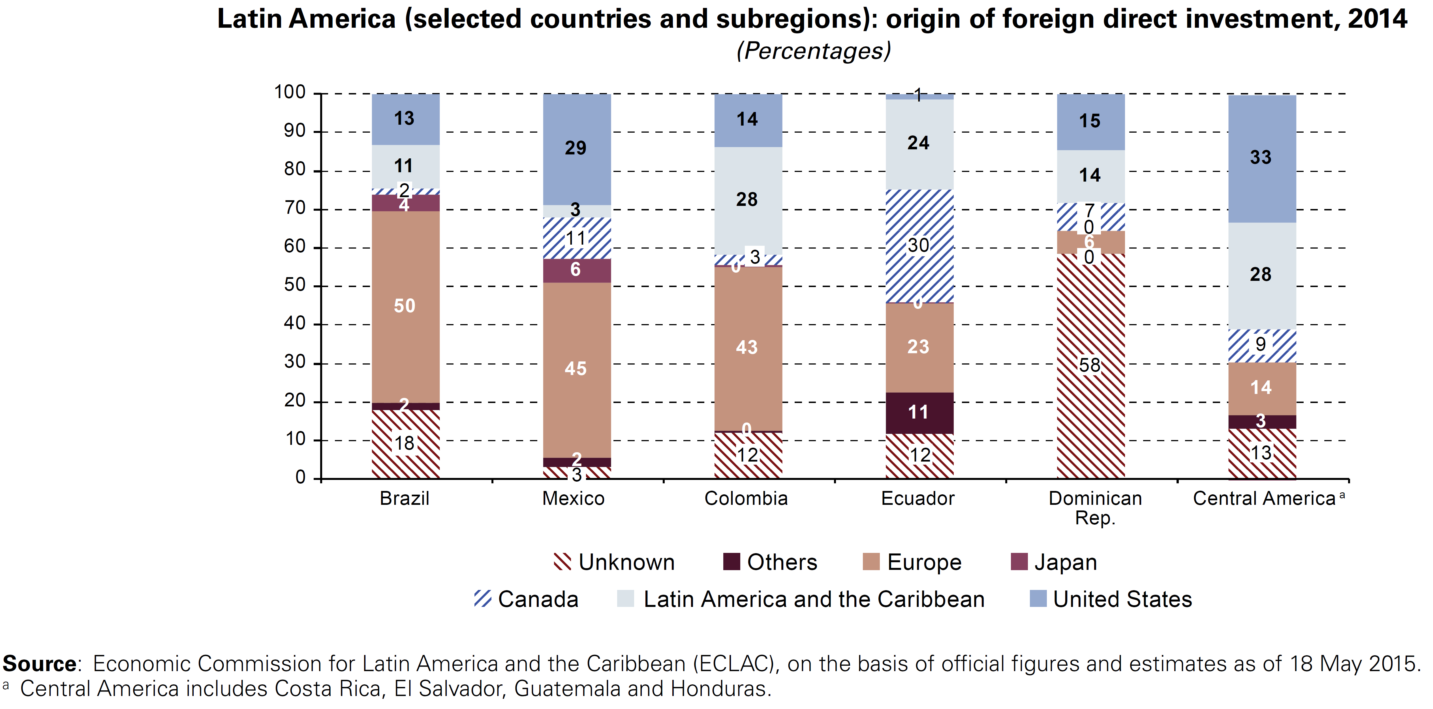

References
- ECLAC (Economic Commission for Latin America and the Caribbean):
- (2015), Foreign Direct Investment in Latin America and the Caribbean, 2015 (LC/G.2641), Santiago, Chile. United Nations publication, Sales No. E.15.II.G.4
- (2014), Foreign Direct Investment in Latin America and the Caribbean, 2014 (LC/G.2613-P), Santiago, Chile. United Nations publication, Sales No. E.14.II.G.4.
- (2013), Foreign Direct Investment in Latin America and the Caribbean, 2013 (LC/G.2571-P), Santiago, Chile. United Nations publication, Sales No. E.13.II.G.4.
- World investment report 2014 [electronic resource] - access mode: http://unctad.org/en/PublicationsLibrary/wir2014_en.pdf

