Synchronous fluorescence spectroscopy for analysis of wines and brandies
Andreeva Ya.L, Bulgaria
Student
Institute of Electronics, Bulgarian Academy of Sciences, Sofia, Bulgaria
Faculty of Physics, Sofia University, Sofia, Bulgaria
E–mail: yana.anndreeva@gmail.com
Synchronous fluorescence spectroscopy is widely used method for analysis of multicomponent systems. [1] This is why it is used in wine and brandy analysis.
The technique is based on simultaneously scanning of the excitation and emission wavelengths while a constant deference Δλ between them is maintained. This is how better discrimination between the peaks, attributed to particular group of fluorophores, is obtained when compared to the standard excitation or emission spectra.
Measurements in this research were made by using FluoroLog3 spectrofluorimeter (HORIBA Jobin Yvon, France) and excitation and emission in the wavelength area 220-700 nm. Wavelength interval Δλ from 10 to 100 nm in 10 nm steps was applied. Excitation and emission slits and increments were set at 3 nm and 5 nm respectively.
Brandies are wine distillates which have been aged in oak barrels for at least 6 months. [2] However there are many unscrupulous producers who used wine distillates mixed with caramel to obtain the color of true brandy. [2] Wine distillates and caramel are cheaper than the true brandy and this is how adulteration leads to profits for manufacturers.
On fig. 1 a) is shown contour plot of the synchronous fluorescence spectra of original brandy. Only one fluorescence maximum is observed, located in the wavelength area around 500 nm in excitation. On fig. 1 b) is presented the obtained spectra of mixed wine distillate with caramel. Additional fluorescence peak appears in the short wavelength area around 430 nm which is attributed to caramel.
a)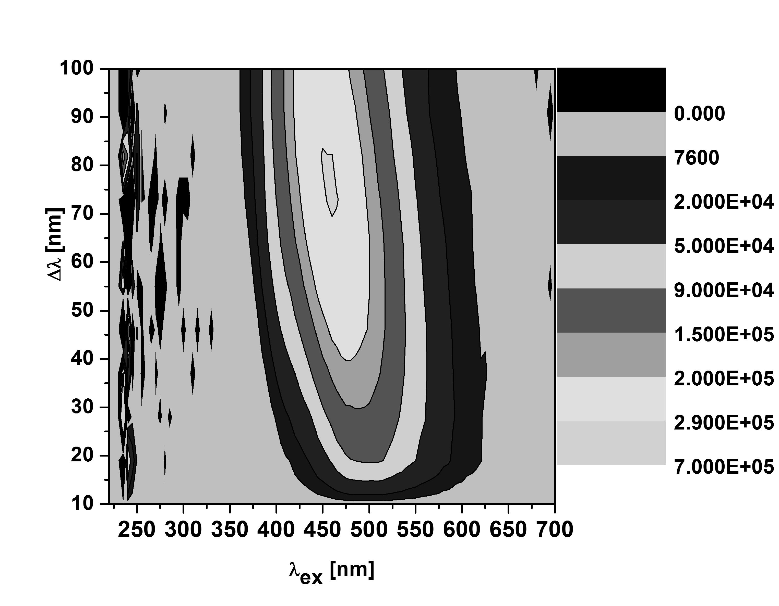b)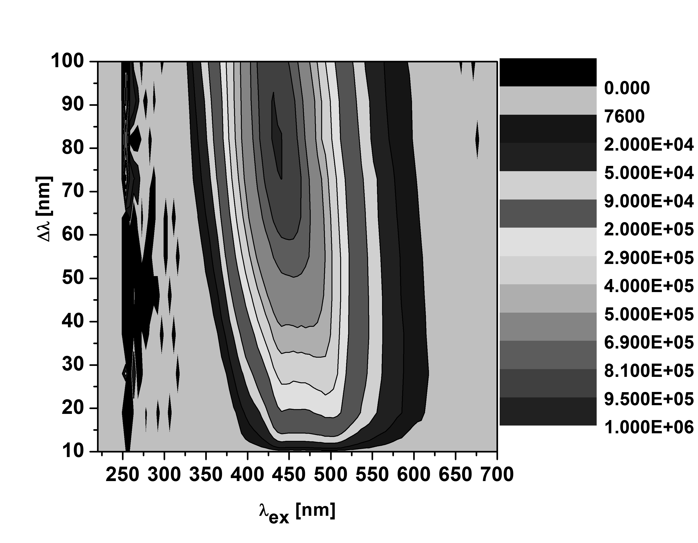
Fig. 1 Contour plots of synchronous fluorescence spectra of: original brandy (a) and adulterated brandy (b).
Comparison between the spectra of homemade wine and wine, produced in winery, can be made by using the results represented on fig. 2. Both samples show fluorescence maximum around 350 nm which is attributed to ferullic, p-coumaric, caffeic acids and etc. Homemade wine gives additional signals around 280 nm in excitation. This peak is assigned to vanillic, syringic and gallic acids. It has been supposed that manufacturing process in winery includes adding of substances, like sodium azide, which are used as bactericides. [3] These compounds eliminate vanillica, syringic and gallic acids. There are potentially toxic for human body.
a) 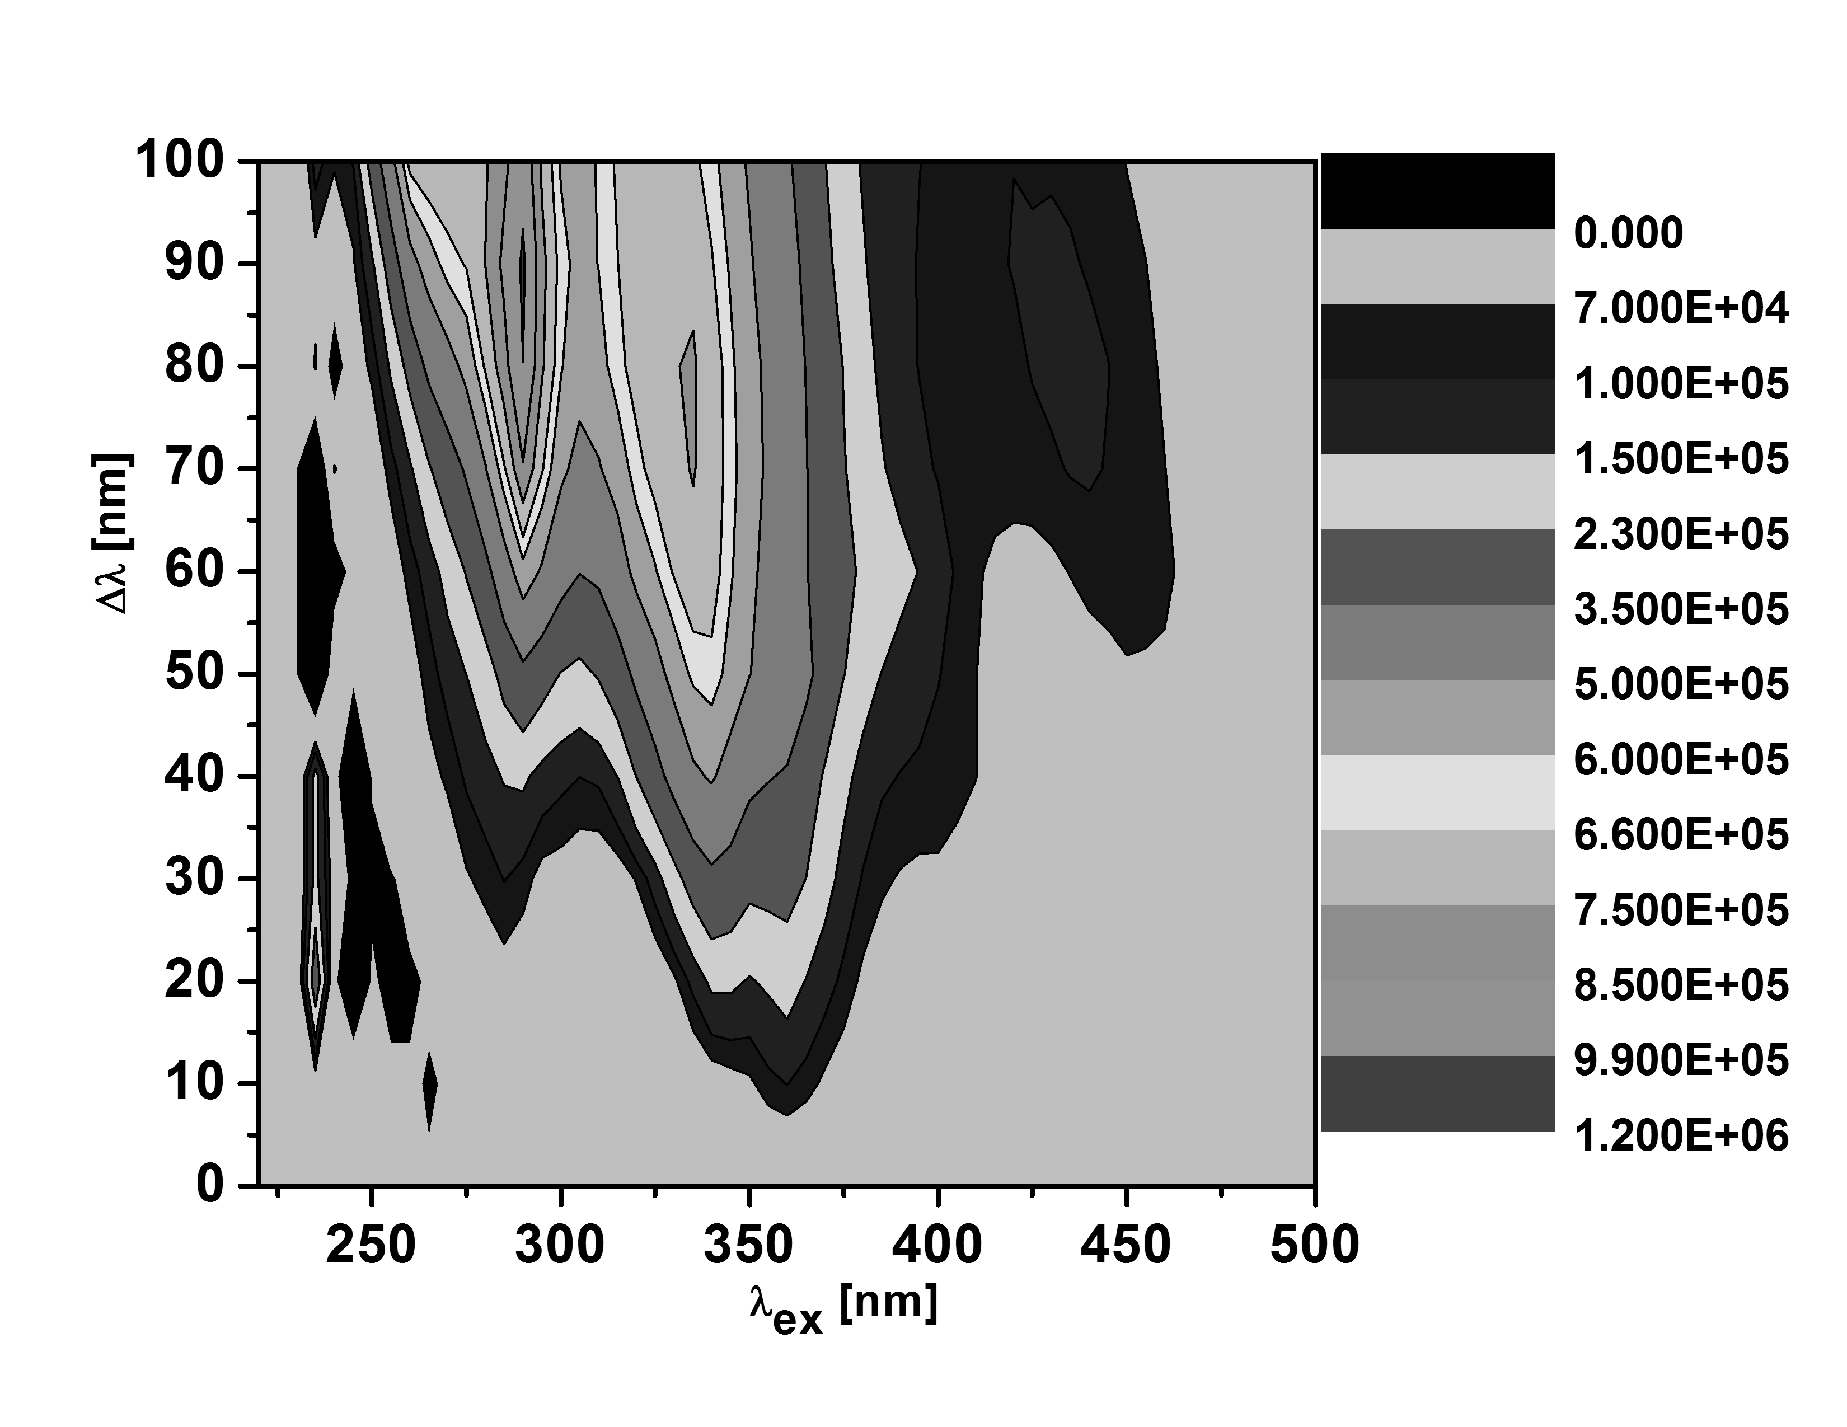b)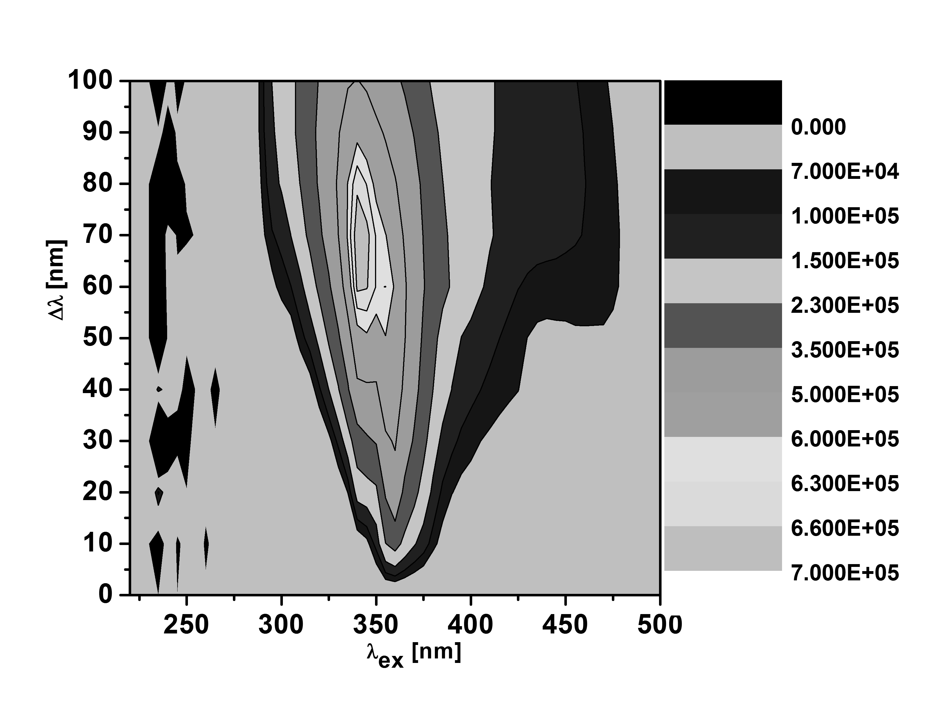
Fig. 2 Contour plots of synchronous fluorescence spectra of: homemade wine (a) and wine produced in winery (b).
***
This study was designed to reveal the potential of synchronous fluorescence spectroscopy in wine and brandy analysis. The need of consumer protection and monitoring of product quality, makes this method very useful and necessary.
Acknowledgements
This work is supervised by Assoc. Prof. Ekaterina Borisova and Prof. Lychezar Avramov.
This work is supported partially by the National Science Fund of Bulgarian Ministry of Education, Youth and Science under grant #DMU-03-46/2011 and grant DO-02-112/2008 and under personal fellowship of E. Borisova from Foundation UNESCO/L’Oreal “For young women in life sciences”, Bulgaria - 2014.
References
- Sádecká, J. and Tóthová, J.: Determination of caramel in non-aged mixed wine spirits by synchronous fluorescence spectroscopъ// Eur Food Res Technol. 2010, №230. p. 797-802.
- Píš, Ľ., Májek, P. and Sádecká, J.: Synchronous fluorescence spectroscopy for differentiating between brandies and wine distillates// Acta Chimica Slovaca. 2011, №4(1). p. 47-58.
- Panossian, A., Mamikonyan, G., Torosyan, M., Gabrielyan, E. and Mkhitaryan, S.: Analysis of aromatic aldehydes in brandy and wine by high-performance capillary electrophoresis// Analytical Chemistry.2001, №73. p. 4379–4383.

